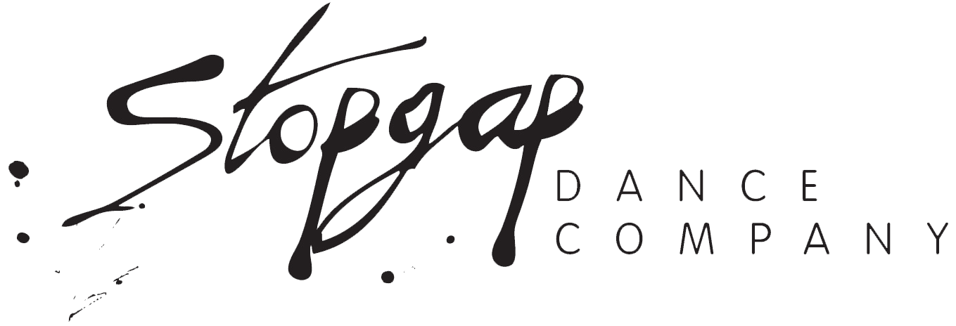

Access Notes

Deaf, Disabled and neurodivergent people are welcome at our intensives, and we hope to create inclusive safe spaces for everyone.

We recognise that everyone’s energy, attention and access needs ebb and flow. As part of our access provision we will make sure certain things are already in place.

Before the training

Please get in touch if you would like any support with the application process.
We can help you with booking onto the training and filling out the sign-up form. If you would prefer submitting a short video or have another way you’d like to apply, please download the ‘alternative applications’ document on the website.
We will also provide…
- an easy-read guide to the teaching team
- how the session will run
- expectations from you working online
- zoom details

During the training

- We welcome engagement in whatever way works best for you
- We use breakout rooms, with the option to remain in the central space
- Be visually and aurally inclusive, meaning presenters will describe key visuals and gestures
- We will enable automated captioning
- Record the session so that you can catch up or revisit at your own pace - we know that life and energy levels aren’t always predictable

After the training

- We will make the recordings available to watch back
- Send on any extra links or resources

For privacy and ethical reasons we are not allowing external AI companions. However, Stopgap have their own and can send out summaries after the training.

Support workers or personal assistants are welcome to join too.

If there is anything that would make it easier for you to take part, you’ll be invited to share your access needs when booking. We’ll do everything we can to meet them.

Please bear in mind that last minute application may have an impact on our ability to fully support all access needs, such as BSL interpreters.

If you have any questions or would like to discuss your access needs, please contact Joy - joy@stopgapdance.com

